CI CD LAB EXPERIMENT-7

(BY: AMAN TYAGI)

Aim: Create a pipeline using Blue Ocean Plugin

1. Start Jenkins
2. Install the blue ocean plugin from manage jenkins

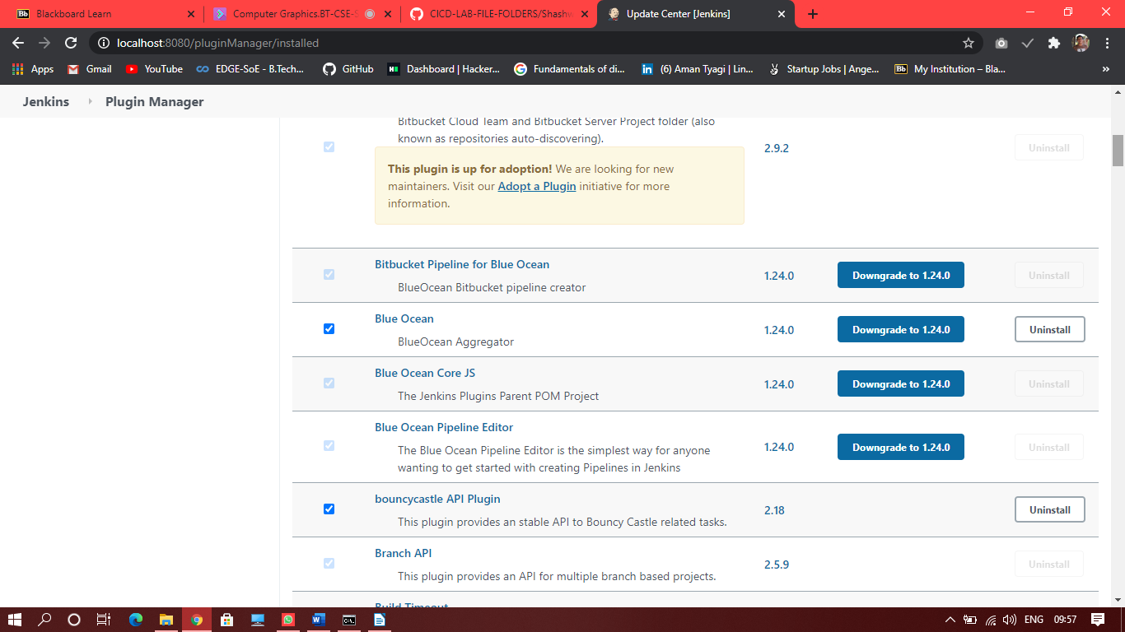

1. When plugin is installed you will see a “open blue ocean” option on the dashboard
2. Then click on that and you will need to authenticate your SCM account and enter the url of the repo with Jenkins File.

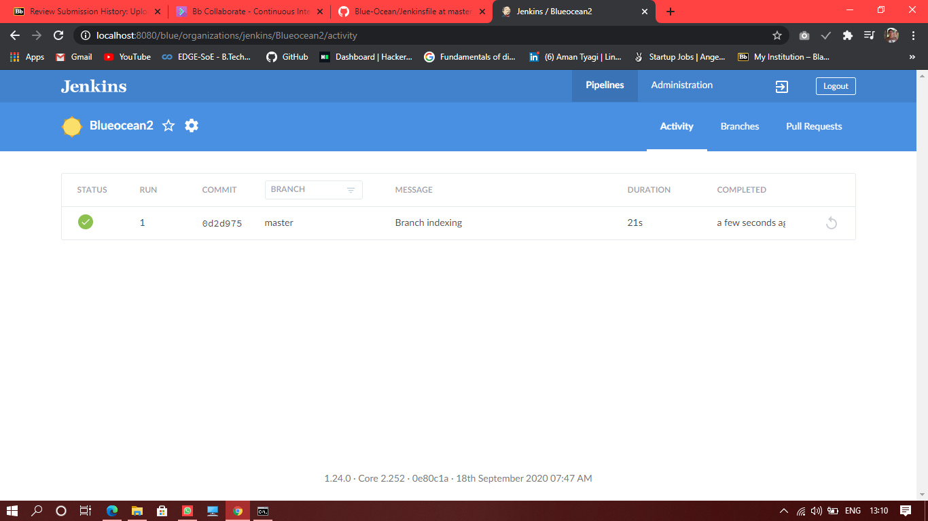

You will see the pipeline created

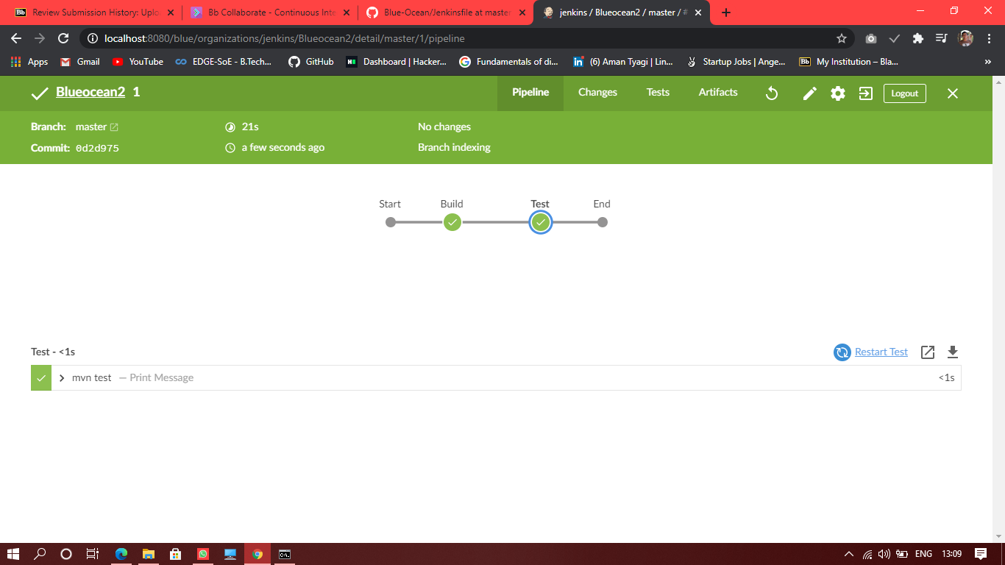

You can also view the commands executed .

